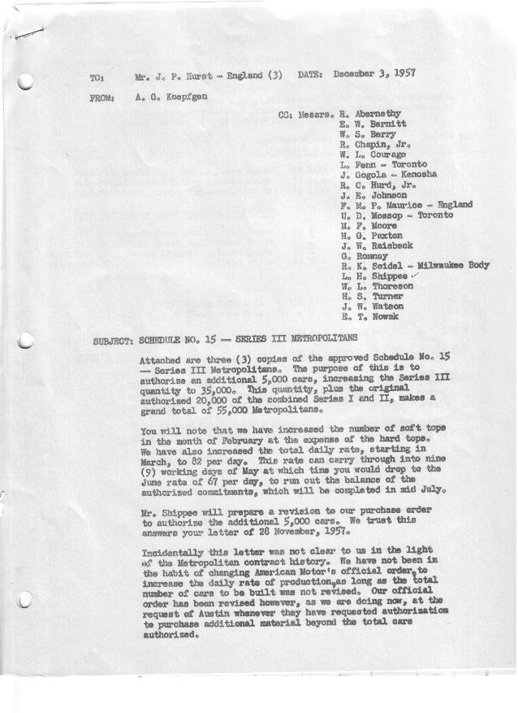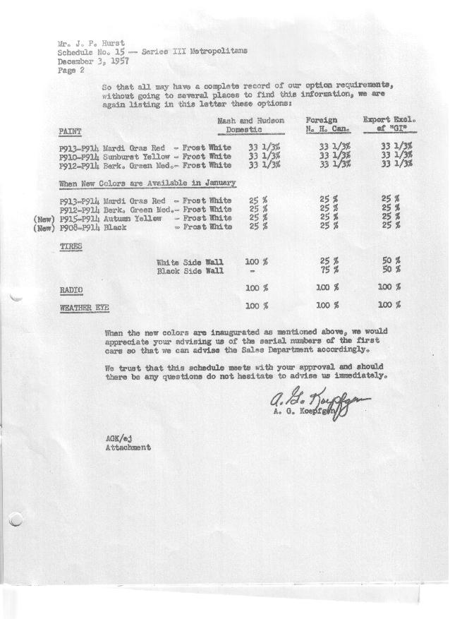

FORM PLAN 68 REV. 2-55-A.M.P Page 1 of 2 APPROVED R. Abernethy (signed) DATE 12-3-57

SCHEDULE NO. ______15 ___ DATE December 3, 1957 MONTHLY BUILDING SCHEDULE APPROVED E.W.Bernitt (signed) ___ _ DATE_ 12-4-57 _
REVISION NO. _______ ______ DATE PRODUCT APPROVED R. W.Chapin Jr. (signed) DATE _ 12-4-57 ____
SERIES III 1500 c.c. ENGINE
METROPOLITAN SERIES CARS – AUSTIN MOTORS CO., LTD, ENGLAND
DESCRIPTION | BUILT  ◻ACTEST  THRU | FIRM BUILDING SCHEDULE  (FABRICATED MATERIAL RELEASE) |  |  |  |  |  |  |  |  |  |  |  |  |  |  | TENTATIVE SCHEDULE  (RAW MATERIAL RELEASED) |  |  | GRAND  TOTAL
DESCRIPTION | BUILT  ◻ACTEST  THRU | MONTH November  DAYS 21 |  |  | MONTH December  DAYS 19 |  |  | MONTH January “58”  DAYS 23 |  |  | MONTH February  DAYS 20 |  |  | MONTH March  DAYS 21 |  |  | MONTH April  DAYS 20 |  |  | GRAND  TOTAL
DESCRIPTION | BUILT  ◻ACTEST  THRU | DAILY | MONTH | CUM’L  TOTAL | DAILY | MONTH | CUM’L  TOTAL | DAILY | MONTH | CUM’L  TOTAL | DAILY | MONTH | CUM’L  TOTAL | DAILY | MONTH | CUM’L  TOTAL | DAILY | MONTH | CUM’L TOTAL | GRAND  TOTAL
DOMESTIC LHD:
Hard-Top | 16567 |  | 1080 | 17647 |  | 1086 | 18733 |  | 1159 | 19892 |  | 914 | 20806 |  | 1109 | 21915 |  | 1122 | 23037
Soft-Top | 2648 |  | 55 | 2703 |  | 130 | 2833 |  | 157 | 2990 |  | 229 | 3219 |  | 277 | 3496 |  | 198 | 3694
Total U.S. | 19215 | 54.0 | 1135 | 20350 | 64.0 | 1216 | 21566 | 57.2 | 1316 | 22882 | 57.2 | 1143 | 24025 | 66.0 | 1386 | 25411 | 66.0 | 1320 | 16731
Over/(Under) Schedule 14 | -0- |  | -0- | -0- |  | -0- | -0- |  | -0- | -0- |  | -0- | -0- |  | 570 | 570 |  | 677 | 1247
FOREIGN:
EXPORT LHD Hard-Top | 605 |  | 65 | 670 |  | 20 | 690 |  | 40 | 730 |  | 30 | 760 |  | 30 | 790 |  | 25 | 815
Soft-Top | 294 |  | 27 | 321 |  | 8 | 329 |  | 12 | 341 |  | 9 | 350 |  | 10 | 360 |  | 8 | 368
Total Export LHD | 899 |  | 92 | 991 |  | 28 | 1019 |  | 52 | 1071 |  | 39 | 1110 |  | 40 | 1150 |  | 33 | 1183
RHD Hard Top | 166 |  | 112 | 278 |  | 14 | 292 |  | 60 | 352 |  | 30 | 382 |  | 30 | 412 |  | 23 | 435
Soft Top | 24 |  | 32 | 56 |  | 6 | 62 |  | 6 | 68 |  | 4 | 72 |  | 10 | 82 |  | 6 | 88
Total Export RHD | 190 |  | 144 | 334 |  | 20 | 354 |  | 66 | 420 |  | 34 | 454 |  | 40 | 494 |  | 29 | 523
Total Export LHD & RHD | 1089 | 11.2 | 236 | 1325 | 2.5 | 48 | 1373 | 5.2 | 118 | 1491 | 3.6(3.7) | 73 | 1564 | 3.8 | 80 | 1644 | 3.8(3.1) | 62 | 1706
Over/(Under) Schedule 14 | -0- |  | -0- | -0- |  | -0- | -0- |  | -0- | -0- |  | -0- | -0- |  | -0- | -0- |  | -0- | -0-
CANADA Hard-Top | 1919 |  | 39 | 1958 |  | 10 | 1968 |  | 110 | 2078 |  | 100 | 2178 |  | 200 | 2378 |  | 200 | 2578
Soft-Top | 148 |  | 0 | 148 |  | 5 | 153 |  | 5 | 158 |  | 30 | 188 |  | 50 | 238 |  | 35 | 273
Total Canada | 2067 | 1.9 | 39 | 2106 | .8 | 15 | 2121 | 5.0 | 115 | 2236 | 6.5 | 130 | 2366 | 11.9 | 250 | 2616 | 11.7 | 235 | 2851
Over/(Under) Schedule 14 | -0- |  | -0- | -0- |  | -0- | -0- |  | -0- | -0- |  | -0- | -0- |  | -0- | -0- |  | 41 | 41
Total Foreign | 3156 | 13.1 | 275 | 3431 | 3.3 | 63 | 3494 | 10.2 | 233 | 3727 | 10.2 | 203 | 3930 | 15.8(15.7) | 330 | 4260 | 14.8 | 297 | 4557
Over/(Under) Schedule 14 | -0- |  | -0- | -0- |  | -0- | -0- |  | -0- | -0- |  | -0- | -0- |  | -0- | -0- |  | 41 | 41
GRAND TOTALS
Hard-Top | 19257 | 61.7 | 1296 | 20553 | 59.5 | 1130 | 21683 | 59.5 | 1369 | 23052 | 53.7 | 1074 | 24126 | 65.2 | 1369 | 25495 | 68.5 | 1370 | 26865
Soft-Top | 3114 | 5.4 | 114 | 3228 | 7.8 | 149 | 3377 | 7.8 | 180 | 3557 | 13.6 | 272 | 3829 | 16.5 | 347 | 4176 | 12.4 | 247 | 4423
Total | 22371 | 67.1 | 1410 | 23781 | 67.3 | 1279 | 25060 | 67.3 | 1549 | 26609 | 67.3 | 1346 | 27955 | 81.7 | 1716 | 29671 | 80.9 | 1617 | 31288
Over/(Under) Schedule 14 | -0- |  | -0- | -0- |  | -0- | -0- |  | -0- | -0- |  | -0- | -0- |  | 570 | 570 |  | 718 | 1288

FORM PLAN 68 REV. 2-55-A.M.P Page 2 of 2 APPROVED R. Abernethy (signed) DATE 12-3-57

SCHEDULE NO. ______15 ___ DATE December 3, 1957 MONTHLY BUILDING SCHEDULE APPROVED E.W.Bernitt (signed) ___ _ DATE_ 12-4-57 _
REVISION NO. _______ ______ DATE PRODUCT APPROVED R. W.Chapin Jr. (signed) DATE _ 12-4-57 ____
SERIES III 1500 c.c. ENGINE
METROPOLITAN SERIES CARS – AUSTIN MOTORS CO., LTD, ENGLAND
DESCRIPTION | BUILT  ◻ACT◻ EST  THRU | FIRM BUILDING SCHEDULE  (FABRICATED MATERIAL RELEASE) |  |  |  |  |  |  |  |  |  |  |  |  |  |  | TENTATIVE SCHEDULE  (RAW MATERIAL RELEASED) |  |  | GRAND  TOTAL
DESCRIPTION | BUILT  ◻ACT◻ EST  THRU | MONTH May  DAYS 22 |  |  | MONTH June  DAYS 19 |  |  | MONTH July  DAYS 12.6 (14 available) |  |  | MONTH  DAYS |  |  | MONTH  DAYS |  |  | MONTH  DAYS |  |  | GRAND  TOTAL
DESCRIPTION | BUILT  ◻ACT◻ EST  THRU | DAILY | MONTH | CUM’L  TOTAL | DAILY | MONTH | CUM’L  TOTAL | DAILY | MONTH | CUM’L  TOTAL | DAILY | MONTH | CUM’L  TOTAL | DAILY | MONTH | CUM’L  TOTAL | DAILY | MONTH | CUM’L TOTAL | GRAND  TOTAL
DOMESTIC LHD:
Hard-Top |  |  | 1122 | 24159 |  | 969 | 25128 |  | 642 | 25770
Soft-Top |  |  | 198 | 3892 |  | 171 | 4063 |  | 87 | 4150
Total U.S. |  | 60.0 | 1320 | 28051 | 60.0 | 1140 | 29191 | 60.4(57.8) | 729 | 29920
Over/(Under) Schedule 14 |  |  | 1320 | 2567 |  | 1140 | 3707 |  | 729 | 4436
FOREIGN:
EXPORT LHD Hard-Top |  |  | 35 | 850 |  | 22 | 872 |  | 19 | 891
Soft-Top |  |  | 12 | 380 |  | 8 | 388 |  | 7 | 395
Total Export LHD |  |  | 47 | 1230 |  | 30 | 1260 |  | 26 | 1286
RHD Hard Top |  |  | 15 | 450 |  | 35 | 485 |  | 30 | 515
Soft Top |  |  | 4 | 92 |  | 5 | 97 |  | 4 | 101
Total Export RHD |  |  | 19 | 542 |  | 40 | 582 |  | 34 | 616
Total Export LHD & RHD |  | 3.0 | 66 | 1772 | 3.7 | 70 | 1842 | 4.9(4.8) | 60 | 1902
Over/(Under) Schedule 14 |  |  | 66 | 66 |  | 70 | 136 |  | 60 | 196
CANADA Hard-Top |  |  | 200 | 2778 |  | 50 | 2828 |  | 52 | 2880
Soft-Top |  |  | 15 | 288 |  | 10 | 298 |  | 0 | 298
Total Canada |  | 9.8 | 215 | 3066 | 3.1 | 60 | 3126 | 4.3(4.1) | 52 | 3178
Over/(Under) Schedule 14 |  |  | 215 | 256 |  | 60 | 316 |  | 52 | 368
Total Foreign |  | 12.8 | 281 | 4838 | 6.8 | 130 | 4968 | 9.2(8.9) | 112 | 5080
Over/(Under) Schedule 14 |  |  | 281 | 322 |  | 130 | 452 |  | 112 | 564
GRAND TOTALS
Hard-Top |  | 62.4 | 1372 | 28237 | 56.6 | 1076 | 29313 | 59.0 | 743 | 30056
Soft-Top |  | 10.4 | 229 | 4652 | 10.2 | 194 | 4846 | 7.8 | 98 | 4944
Total |  | 72.8 | 1601 | 32889 | 66.8 | 1270 | 34159 | 66.8 | 841 | 35000
Over/(Under) Schedule 14 |  |  | 1601 | 2889 |  | 1270 | 4159 |  | 841 | 5000

